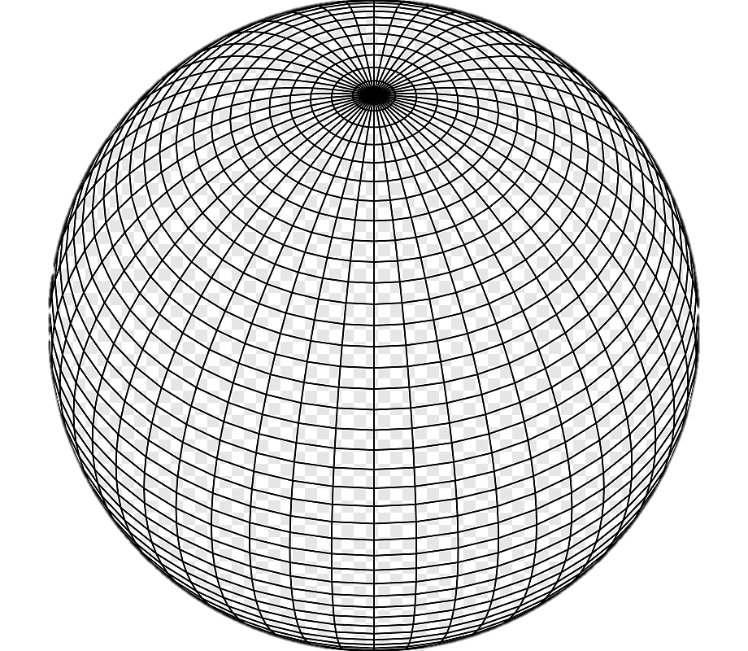

**Sfer4D**

**“Building Digital Universes”**